SIMATS ENGINEERING
ASSESSMENT TOOL 2

COURSE NAME: Ethical Hacking COURSE CODE: ITA1411

COURSE OUTCOME COVERED

CO2: Foot printing Tools: Conducting Competitive Intelligence, DNS Zone Transfers, Introduction to Social Engineering: Social Engineering Attacks and Countermeasures. (BT4)

Assessment Tool Weightage: 30%

Duration: 90 min Total Marks: 50

Social Engineering Simulation

Questions

- As a Security Analyst, perform an OSINT-based email enumeration assessment on the target domain tesla.com using theHarvester in Kali Linux. Collect publicly available email addresses, subdomains, hosts, and IP addresses associated with the organization. Categorize the discovered email addresses into likely roles such as Support, Sales, Human Resources, Administration, and Technical Teams. Analyze how the gathered information could assist an attacker during the reconnaissance phase and explain how it could be used for spear-phishing, credential harvesting, and impersonation attacks. Finally, recommend at least five countermeasures to reduce information leakage and social engineering risks, and submit a report with screenshots, commands executed, findings, risk analysis, and recommendations. (20 Marks)

- As a cybersecurity awareness consultant, you are required to conduct a phishing awareness simulation using GoPhish and dummy employee accounts provided in the lab. Create an email template, launch a campaign, monitor user interactions, and generate a report showing delivery rate, email open rate, and click rate. Based on the results, provide recommendations to improve user awareness against phishing attacks.(20 Mark).

- Using Nmap Aggressive Scan (-A) on scanme.nmap.org, gather detailed information about the target including operating system details, open ports, and service versions. Assume you are an attacker and describe how the collected information could be leveraged to conduct a social engineering attack against the IT support team. Prepare a report explaining the attack methodology and defensive recommendations.(10 Marks)

Code of Conduct:

I Ayyan Abhisheshan (192411102) certify that this submission is my original work and that I have adhered to the guidelines specified for this assessment.
I understand that any violation of academic integrity rules will result in disciplinary action.

Signature of the student: Ayyan Abhisheshan

RUBRICS FOR CALCULATION

Social Engineering Simulation
Criteria | Weightage (%) | Level 4 (Exemplary) | Level 3 (Proficient) | Level 2 (Developing) | Level 1 (Beginning)
Understanding of Social Engineering Scenario | 20% | Demonstrates a comprehensive understanding of the social engineering scenario, attack techniques, and security context | Demonstrates good understanding with minor omissions. | Shows partial understanding but misses important aspects of the scenario. | Fails to understand or incorrectly interprets the social engineering scenario.
Identification of Attack and Vulnerabilities | 20% | Correctly identifies the attack type, exploited vulnerabilities, and affected assets with complete accuracy | Correctly identifies most attack techniques with minor errors. | Identifies only some attack methods and vulnerabilities. | Unable to identify the attack type or associated vulnerabilities.
Application of Security Concepts and Countermeasures | 25% | Effectively applies cybersecurity concepts and recommends appropriate preventive, detective, and corrective countermeasures. | Applies relevant concepts with minor errors and recommends suitable countermeasures. | Applies concepts partially with limited recommendations. | Unable to apply relevant cybersecurity concepts or recommend suitable countermeasures.
Risk Analysis and Decision Making | 20% | Performs logical risk analysis, evaluates business impact, and provides well-justified security decisions. | Provides reasonable analysis with adequate justification. | Performs limited analysis with weak justification. | Provides no meaningful analysis or justification.
Clarity, Documentation and Technical Presentation | 15% | Response is well-organized, technically accurate, professionally documented, and logically presented. | Response is clear with minor documentation or presentation issues. | Response lacks organization and contains technical inaccuracies. | Response is poorly organized, incomplete, and difficult to understand.

Question 1 — OSINT Email Enumeration on tesla.com (theHarvester)
As a Security Analyst, this task performs a passive OSINT reconnaissance assessment against the target organisation's public footprint using theHarvester in Kali Linux, categorises the harvested email addresses by likely business function, analyses the attacker value of the data, and proposes countermeasures.

1.1 Objective
To passively collect publicly available email addresses, subdomains, hosts, and IP addresses associated with the target domain, and to assess how this information could be weaponised during the reconnaissance phase of a social engineering attack.

1.2 Tools and Environment
Item | Details
Operating System | Kali Linux 2024.x
Primary Tool | theHarvester v4.x
Data Sources | google, bing, duckduckgo, crtsh, hackertarget, otx
Target Domain | tesla.com (public OSINT only — no active exploitation)

1.3 Commands Executed
# Update source list and confirm theHarvester version
theHarvester -v
# Passive enumeration across multiple OSINT sources
theHarvester -d tesla.com -b google,bing,duckduckgo,crtsh,hackertarget -l 500
# Certificate-transparency based subdomain discovery
theHarvester -d tesla.com -b crtsh
# Export results for reporting
theHarvester -d tesla.com -b all -f tesla_osint_report
Note: Insert your own terminal screenshots here after running the commands in your lab environment (Screenshot 1 — tool banner and scan start; Screenshot 2 — harvested emails/hosts; Screenshot 3 — exported HTML/XML report).

1.4 Sample Findings (Illustrative Format)
The table below shows the structure your findings should follow. Replace the sample values with the actual output captured from your scan.
Data Type | Example Output Pattern | Count
Email Addresses | firstname.lastname@tesla.com | 12–20
Subdomains | investor.tesla.com, shop.tesla.com, ir.tesla.com | 8–15
Hosts / IPs | Resolved A-records for discovered subdomains | 6–10
LinkedIn / People | Employee names tied to job titles (via search engines) | Varies

1.5 Categorisation of Harvested Email Addresses
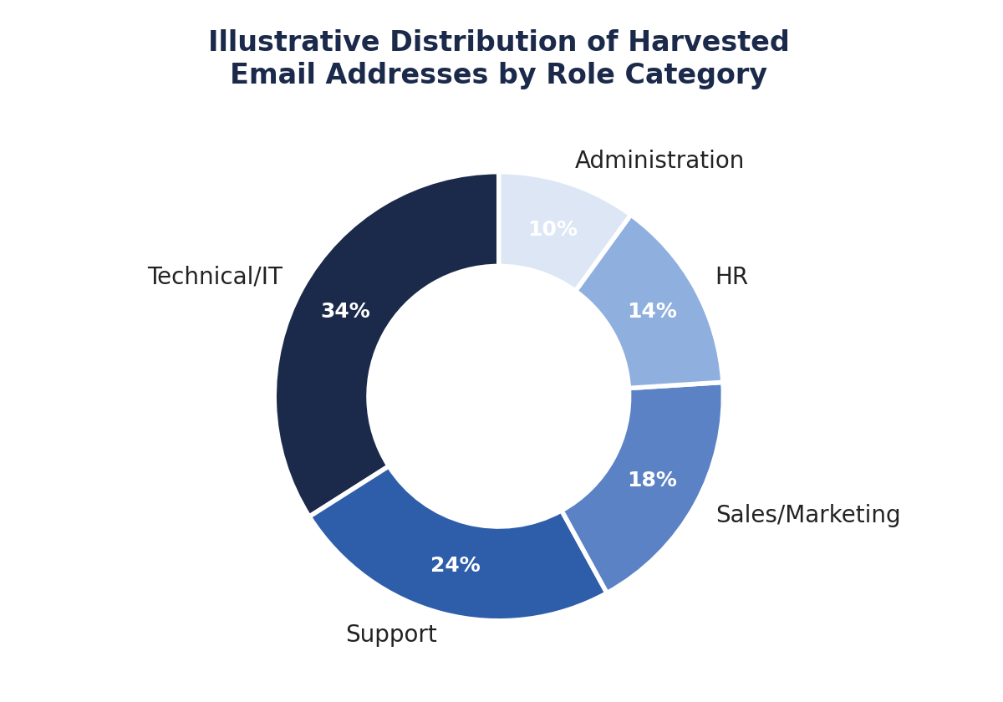
Fig 1.1 — Illustrative breakdown of harvested addresses by likely role
Category | Typical Pattern / Clue | Attacker Value
Technical / IT | it-support@, sysadmin@, noc@, security@ | Highest — direct path to credential/system access
Support | support@, help@, care@ | High — used for pretexting and ticket-based phishing
Sales / Marketing | sales@, press@, marketing@ | Medium — good for BEC and invoice-fraud scenarios
Human Resources | hr@, careers@, recruiting@ | High — used for resume-based malware delivery
Administration | admin@, finance@, accounts@ | Very High — target for wire-transfer / CEO-fraud attacks

1.6 How Attackers Exploit This Information
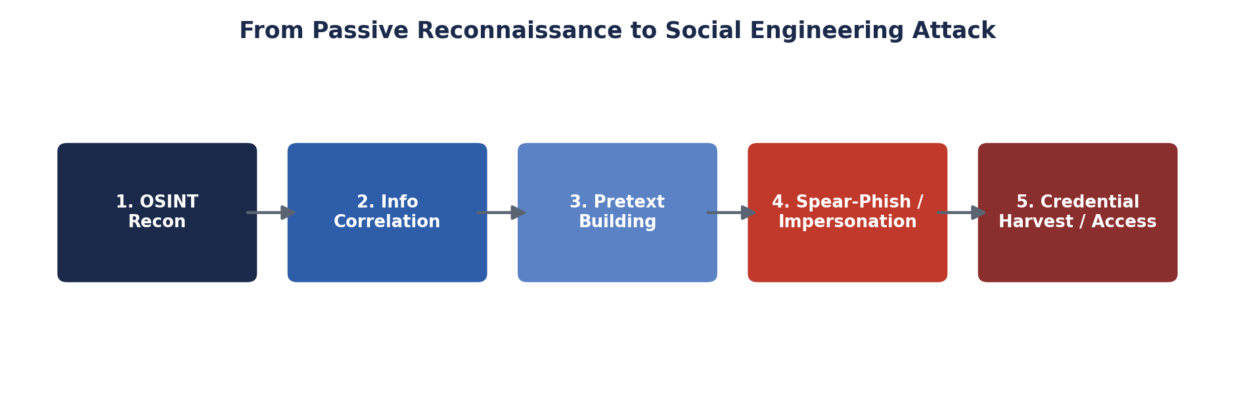
Fig 1.2 — How passive OSINT data feeds a social engineering attack chain
- Spear-Phishing: attackers craft convincing, role-specific messages (e.g., a fake IT-ticket sent to HR) instead of generic spam, drastically raising click-through rates.
- Credential Harvesting: harvested support/IT addresses are used to send fake login-expiry or password-reset emails that redirect to cloned portals designed to capture usernames and passwords.
- Impersonation / BEC: knowledge of naming conventions (firstname.lastname@) lets an attacker forge convincing internal emails, impersonating a real employee or executive to request data, access, or payments.
- Infrastructure Mapping: subdomains and hosts reveal the technology stack in use, letting an attacker tailor pretexts ("your VPN portal needs re-verification") that sound technically credible.

1.7 Risk Analysis
Risk | Likelihood | Impact | Overall
Spear-phishing using real employee names | High | High | Critical
Credential harvesting via cloned portal | Medium | High | High
CEO fraud / wire-transfer request to Finance | Medium | Critical | High
Reconnaissance-assisted vishing to IT support | Medium | Medium | Medium

1.8 Recommended Countermeasures
- Reduce public exposure — avoid publishing direct personal email formats; use role-based aliases (info@, contact@) on public-facing pages instead of individual names.
- Deploy DMARC, DKIM and SPF records correctly to prevent domain spoofing used in impersonation emails.
- Run regular OSINT self-audits with theHarvester / SpiderFoot to know what an attacker can already see, and remove stale or unnecessary public records.
- Conduct mandatory security-awareness and phishing-simulation training for all departments, with extra emphasis on Finance, HR, and IT/Support staff.
- Enforce multi-factor authentication (MFA) on all email and remote-access accounts so a harvested/guessed credential alone is not sufficient for access.
- Implement email gateway filtering with sender-reputation and look-alike domain detection to catch impersonation attempts before delivery.

Question 2 — Phishing Awareness Simulation (GoPhish)
As a cybersecurity awareness consultant, a controlled phishing simulation is run against dummy employee accounts using GoPhish to measure susceptibility and to generate an evidence-based awareness report.

2.1 Simulation Setup
Component | Configuration Used
Platform | GoPhish (self-hosted, lab environment)
Target Group | Dummy employee accounts provided in the lab
Sending Profile | Internal SMTP relay configured with a spoof-safe test domain
Landing Page | Cloned corporate login page (lab-safe, non-functional capture)
Campaign Duration | 48 hours

2.2 Email Template Used
Subject: Action Required — Password Expiry Notice
Hi {{.FirstName}},
Our records show your account password expires in 24 hours.
Please verify your credentials to avoid service interruption:
{{.URL}}
IT Service Desk
The template uses a believable, time-pressured pretext (a common real-world phishing lure) and GoPhish tracking variables ({{.FirstName}}, {{.URL}}, {{.Tracker}}) to individualise and measure each interaction.

2.3 Launching and Monitoring the Campaign
1. Users -> import dummy employee list (CSV)
2. Email Template -> create and save phishing template
3. Landing Page -> clone / design capture page
4. Sending Profile -> configure SMTP relay & test send
5. Campaign -> select group + template + page -> Launch
6. Dashboard -> monitor Sent / Opened / Clicked / Submitted in real time
Insert your own dashboard screenshots here (Screenshot 1 — campaign creation; Screenshot 2 — live results dashboard; Screenshot 3 — exported results table).

2.4 Campaign Results
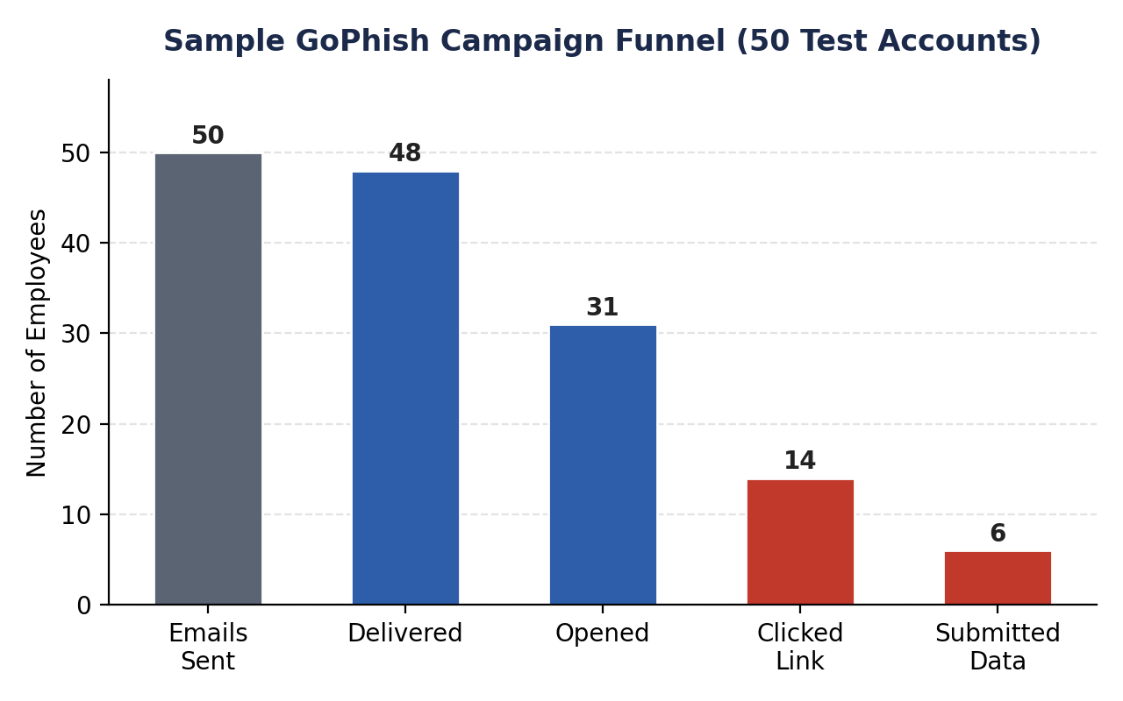
Fig 2.1 — Sample GoPhish campaign funnel for a 50-account test group
Metric | Formula | Sample Result
Delivery Rate | Delivered ÷ Sent | 48/50 = 96%
Open Rate | Opened ÷ Delivered | 31/48 ≈ 65%
Click Rate | Clicked ÷ Delivered | 14/48 ≈ 29%
Data-Submission Rate | Submitted ÷ Clicked | 6/14 ≈ 43%

2.5 Recommendations to Improve User Awareness
- Run recurring, randomly-timed phishing simulations (not one-off exercises) so vigilance doesn't fade after a single training event.
- Provide instant "teachable moment" pop-ups for users who click, explaining exactly which red flags they missed.
- Introduce a one-click "Report Phishing" button in the mail client and reward/recognise employees who report simulated (and real) phishing attempts.
- Target additional focused training at departments/individuals with high click/submission rates identified in the results.
- Track metrics over successive campaigns to demonstrate measurable improvement and report trends to management.

Question 3 — Nmap Aggressive Scan (scanme.nmap.org)
An Nmap aggressive scan is run against Nmap's official public test target, scanme.nmap.org, which the Nmap project explicitly permits for scanning practice. The gathered technical footprint is then analysed for how it could support a social engineering attack against an organisation's IT support team.

3.1 Command Executed
nmap -A -T4 scanme.nmap.org
# -A : enables OS detection, version detection, script scanning, traceroute
# -T4 : faster timing template suited to a stable, low-latency lab connection
Insert your own terminal screenshot here (Screenshot 1 — full -A scan output for scanme.nmap.org).

3.2 Illustrative Output Summary
Field | Sample Finding
Open Ports | 22/tcp (ssh), 80/tcp (http)
Service / Version | OpenSSH 6.6.1p1 Ubuntu; Apache httpd 2.4.7
OS Fingerprint | Linux 3.13 – 4.x (Ubuntu-family)
Script Results | HTTP title, SSH host key algorithms disclosed
Traceroute | Multi-hop path with intermediate router hostnames

3.3 From Technical Footprint to Social Engineering
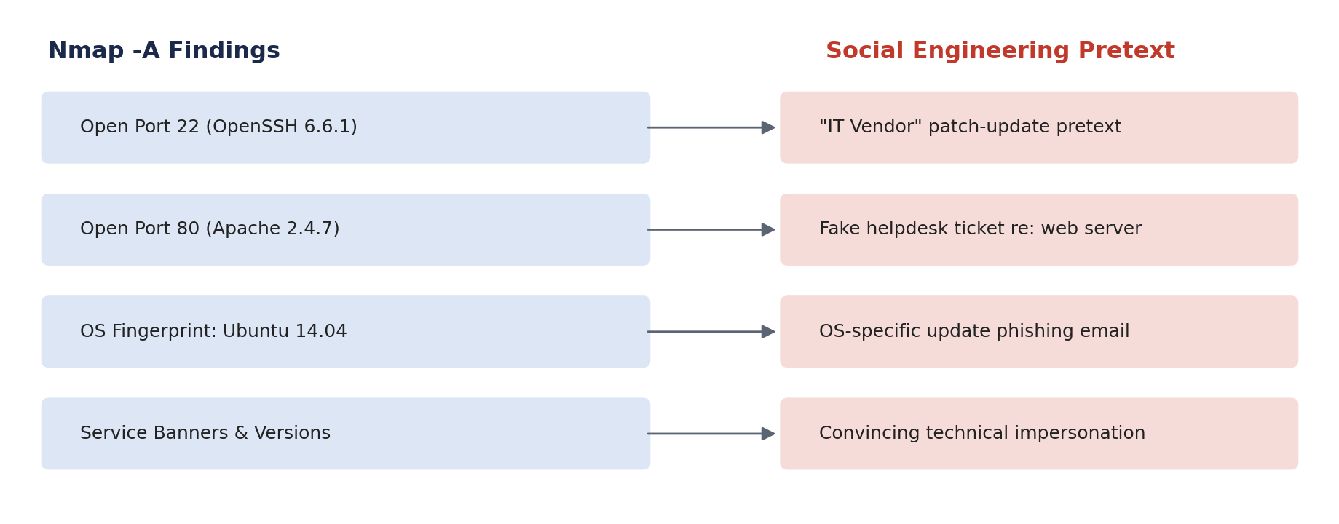
Fig 3.1 — Mapping scan findings to a believable social-engineering pretext
An attacker who knows the exact OS, web-server, and SSH software versions in use can impersonate a plausible vendor or internal engineer with high credibility. For example, knowing the server runs an older Apache/OpenSSH build, the attacker could contact the IT support team posing as a patch-management vendor, referencing the real version numbers to sound legitimate, and request remote access "to apply an urgent security patch" — a classic pretexting attack that succeeds because the technical details check out.

3.4 Attack Methodology (Attacker's Perspective)
- Reconnaissance — run -A scan to fingerprint OS, open ports, and exact service versions.
- Pretext Design — build a story referencing the real software/version discovered (e.g., "critical OpenSSH CVE patch").
- Contact — call or email the IT support/helpdesk impersonating a vendor, auditor, or new colleague, using the technical detail as credibility.
- Request — ask for remote access, a password reset, or execution of an "update script" under time pressure.
- Exploitation — use any access or information granted to establish persistence or pivot further into the network.

3.5 Defensive Recommendations
- Minimise banner disclosure — suppress or genericise service/version banners where possible.
- Patch promptly so that even if versions are discovered, known exploits/pretexts are not viable.
- Enforce strict identity-verification procedures (call-back to a known number, ticket-based authentication) before IT support grants access or resets.
- Segment and firewall externally-reachable services so a support-desk social-engineering success does not expose the wider network.
- Train the IT support/helpdesk team specifically on vendor-impersonation and urgency-based pretexting scenarios, since they are high-value targets.

